Exploratory Data Analysis on the Diabetes Dataset
Report

Introduction
This report presents an exploratory data analysis of the Diabetes dataset, which contains standardised medical measurement for a group of patients. The primary objective is to investigate how various physiological and metabolic features relate to the target variable: disease progression one year after initial point of measurement.
The dataset includes 10 independent variables (age, sex, bmi, bp, s1-s6) and one dependent variable (progression). All features are numeric and standardised to zero mean and unit variance, allowing for direct comparison and correlation analysis.
Data cleaning
The dataset was first inspected for structure, consistency and readiness for analysis. All features were numeric and standardised. This allowed for direct comparison across variables without additional scaling.
Key steps:
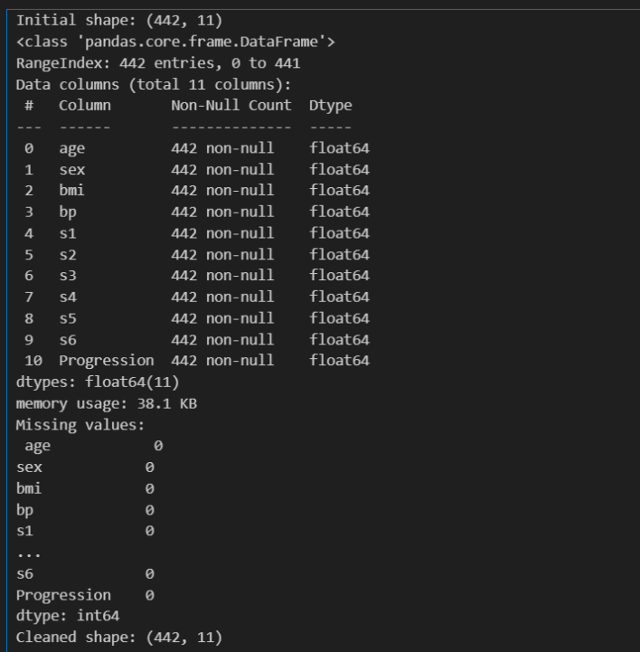
- Structural check: verified shape and column names using .shape and .info()
- Missing value check: used .isnull().sum() to confirm no missing entries.
- Data integrity: Ensured all columns were of type float64, suitable for statistical analysis.
- Visual confirmation: A distribution plot of the target variable was generated to assess asymmetry and spread. These steps ensured the dataset was clean and ready for analysis.
Figure 1: Dataset Info and Missing Value Summary
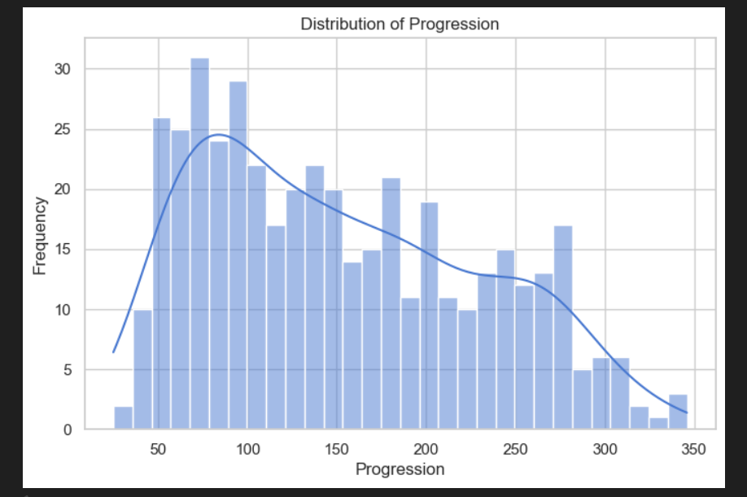
Figure 2: Distribution of Diabetes Progression Scores

Missing data
A full column-wise inspection revealed no missing values in the dataset. As a precaution:
- .dropna() was applied to ensure robustness.
- Defensive coding practices were used to prevent runtime errors in future analysis.
The dataset was clean and ready for analysis.
Data stories and visualisations
This section explores relationships between features and the target variable using visual and statistical methods.
Descriptive Statistics:
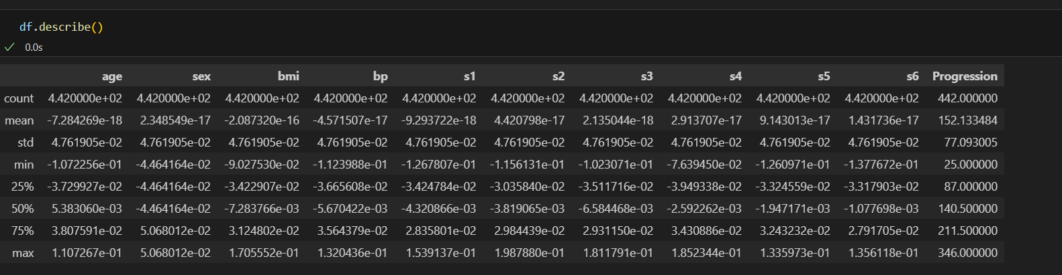
The dataset shows a wide range of values across features, with Progression ranging from approximately 25 to 346.
Figure 3: Summary Statistics for All Features
Correlation Statistics:
A heatmap of Pearson correlations revealed:
- Strong positive correlation between bmi, s5, and Progression.
- Moderate correlation with bp and age.
- Negative or weak correlations with s3, s6, and sex.
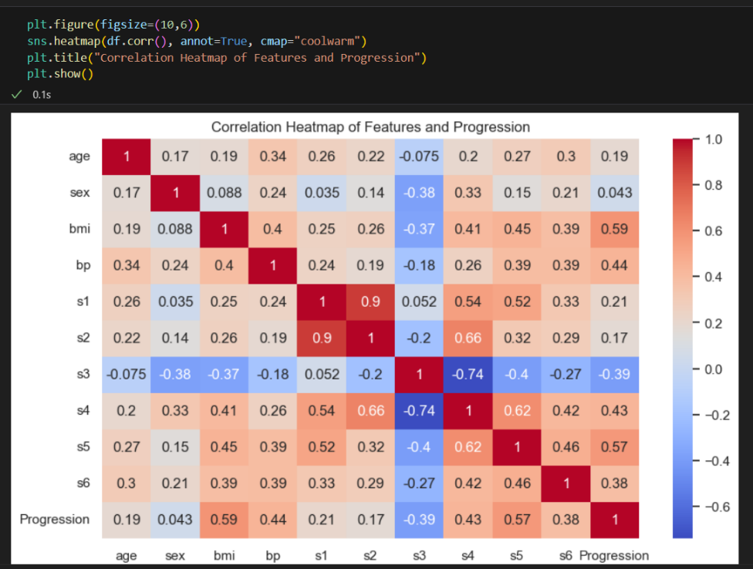

Figure 4: Pearson Correlation Heatmap
Comparisons:
Scatterplots were used to compare individual features against Progression:
- BMI vs Progression: Clear upward trend; higher BMI is associated with more severe progression.
- S5 vs Progression: Strong linear relationship; s5 (log of serum triglycerides) is a key predictor.
- Age vs Progression: Older patients tend to show higher progression scores.
- BP vs Progression: Positive but less pronounced correlation.

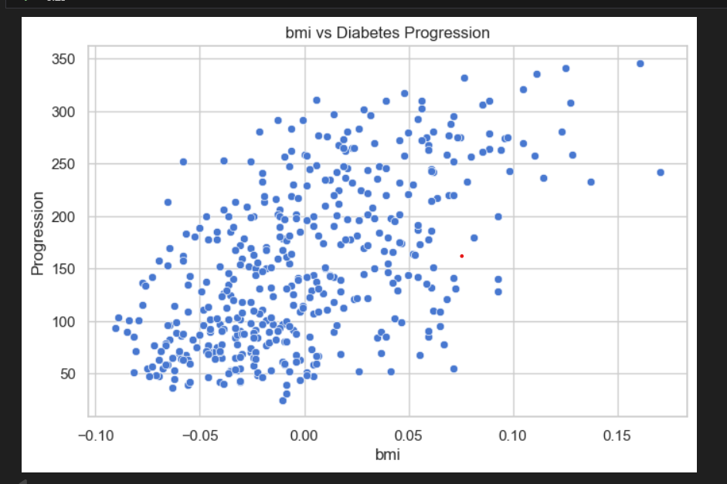

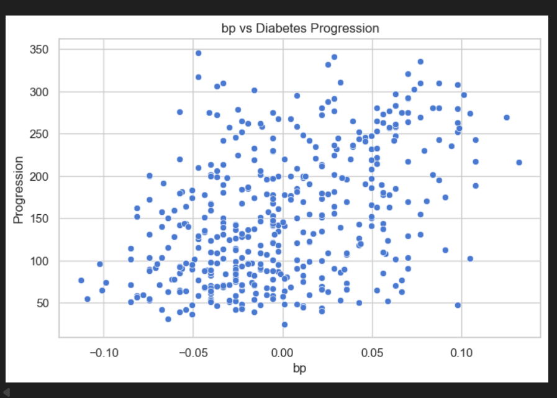
Figure 5: BMI Compared to Diabetes Progression

Figure 6: Blood Pressure Compared to Diabetes Progression
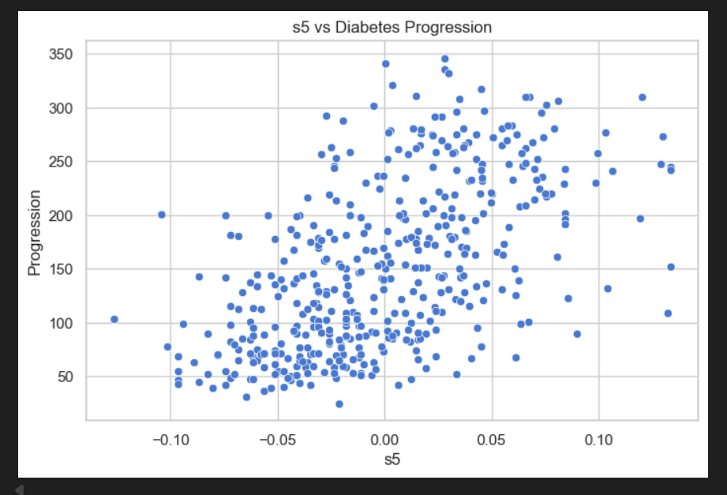

Figure 7: Serum Triglycerides (S5) vs Progression
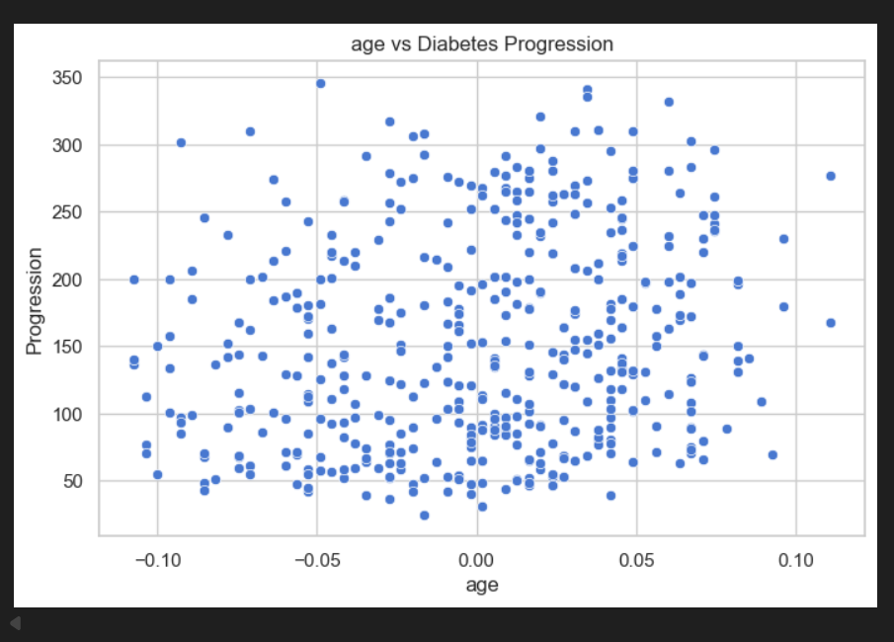
Figure 9: Age Compared to Diabetes Progression

Key Findings
BMI and S5 are the strongest predictors of diabetes progression.
- Age and blood pressure also contribute meaningfully to outcome variability.
- The dataset is well-suited for regression modelling and further predictive analysis.
- No data quality issues were found, and all features are statistically valid.

Conclusion
This EDA has revealed meaningful relationships between physiological features and diabetes progression. The strongest indicators include BMI, age, and serum triglyceride levels (s5). These insights can inform future modelling efforts, such as linear regression or decision trees, to predict disease outcomes and support clinical decision-making.

This report was written by:
Danielle Lawrence

